# Introduction

# Chapter 1: requirements

This is the first step in our project or anyone ,so in this step we will describe by details all part of requirement by requirement diagram.

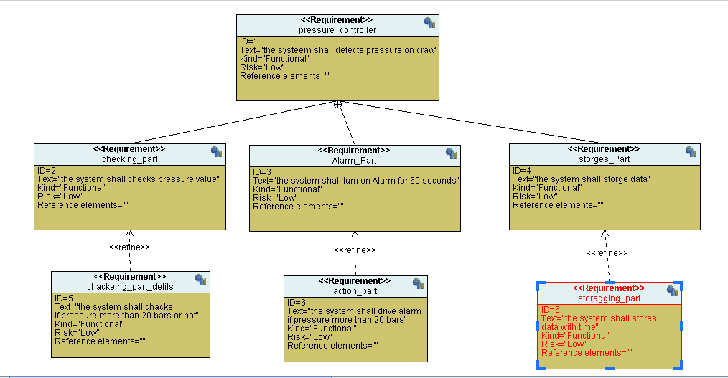

1-pressure sensor will check pressure value on plane

2-when pressure exceeds 20 bars Alarm will drive to 60 second

3-At this time ROM will gets a signal carries pressure value and time information.

# Chapter 2: System Analysis

This step describes main components of systems and we have three methods of system analysis.

1. Use Case Diagram :

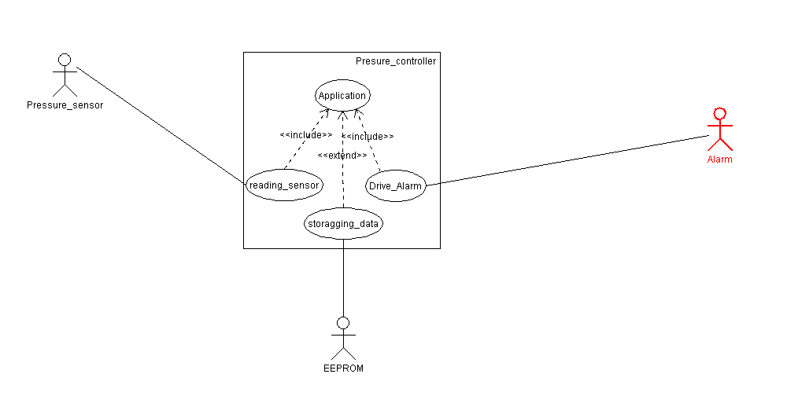

1. Hardware Components:

Pressure sensor , Alarm and EEPROM.

1. Software components:
2. Include

Reading sensor

Alarm Driver

1. Extended

## 2- Activity Diagram

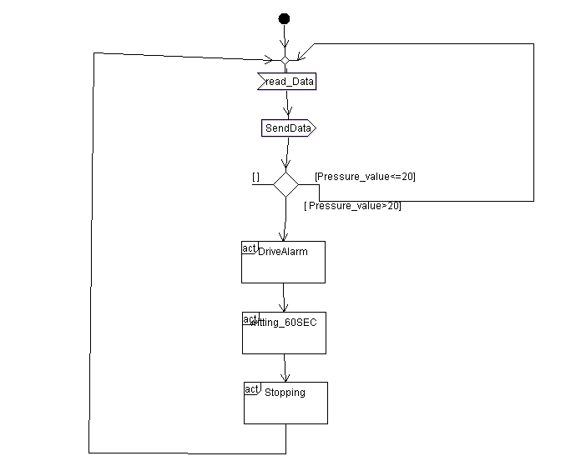

1- sensor shall checks pressure at cabin

2- system shall checks pressure value if it exceeds 20 bars .

3- Alarm will be on to 60 sec and stop

## 3- Sequence Diagram:

This sequence describes Scenario of system when is driving.

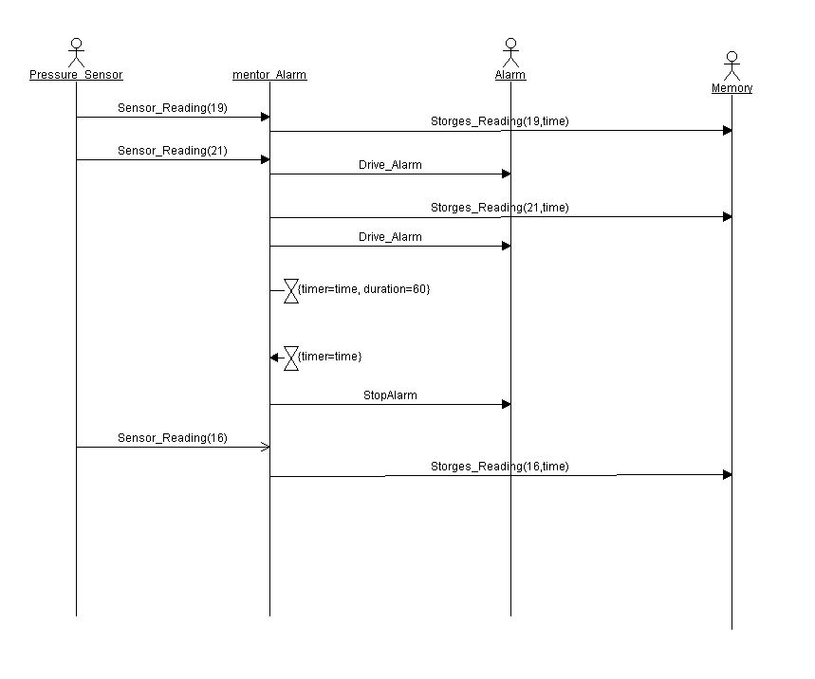

# Chapter 3: System Design

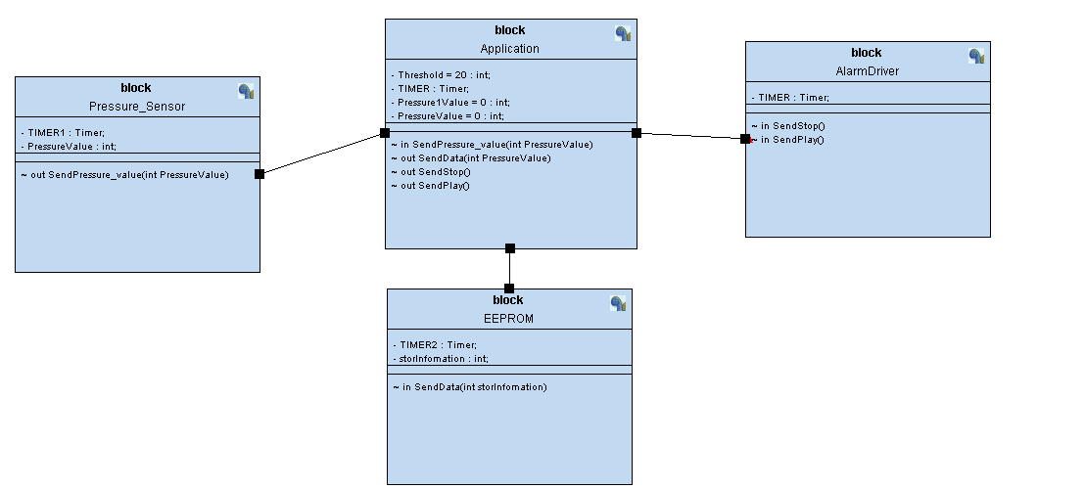

## 1- Application:

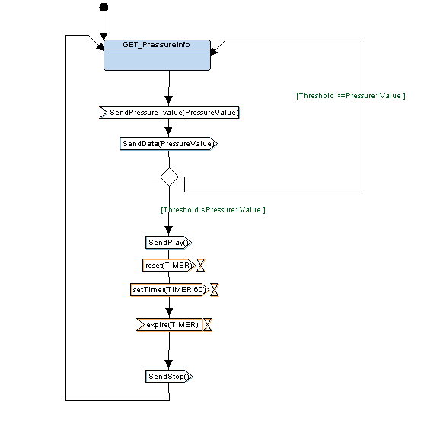

## 2- Pressure sensor

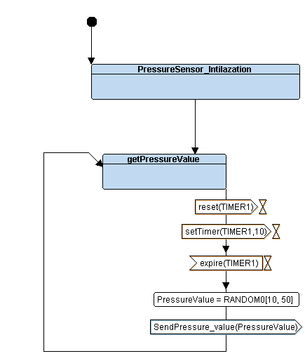

## 3- Alarm driver

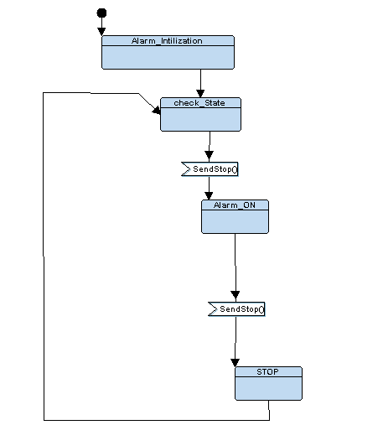

## 4- EEPROM

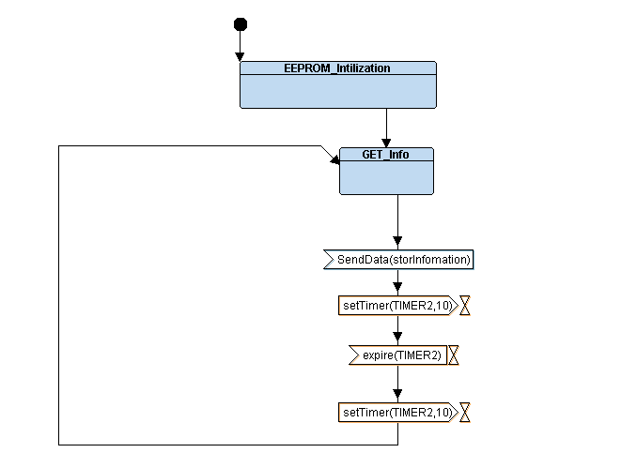

# Chapter4: toolchain

In this chapter we will create our toolchain that will help us to implement binary file or hex file

## 1- Startup code:

It is a part of startup code necessary to run our code ,It has vector table and it branches to main function.

The first address in this file is address of stack pointer stores in flash at first address and (_reset ) symbol

Using when processor get reset massage by hardware it will branches to main.

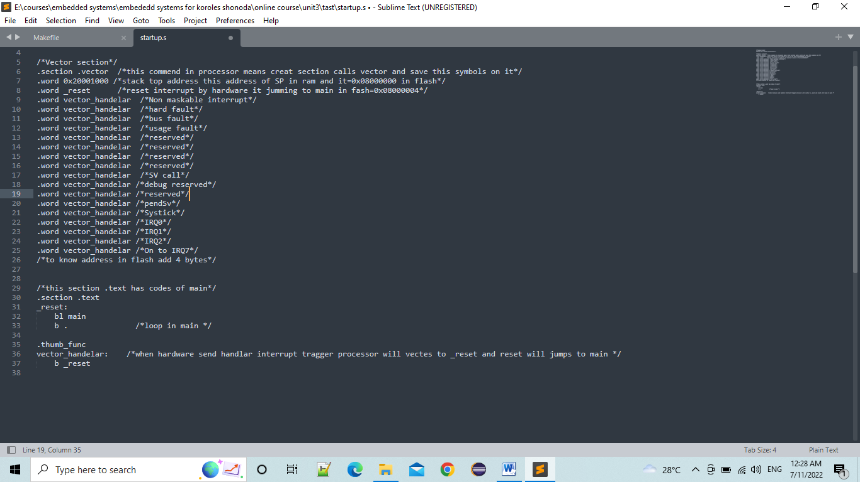

## 2-linker script

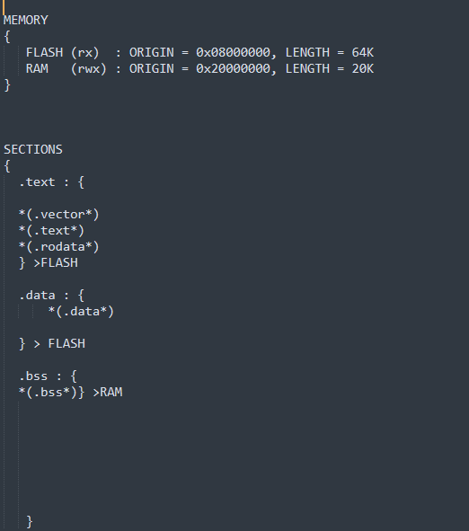

In this file we divided memory to some section

NOT in this project we will working in FLASH.

**.Data**

.bss

RAM

.rodata

.text

.vector

.text

**FLASH**

## 3- Makefile

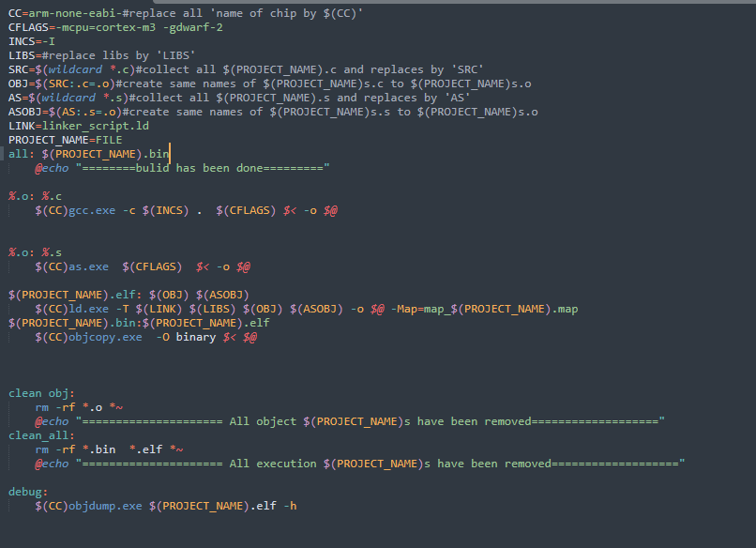

# Cahpter5: software

<https://github.com/mahmoudgaber97/term_project/tree/main/pressure%20controller/CODE>

# chapter6: Hardware

## circuit diagram

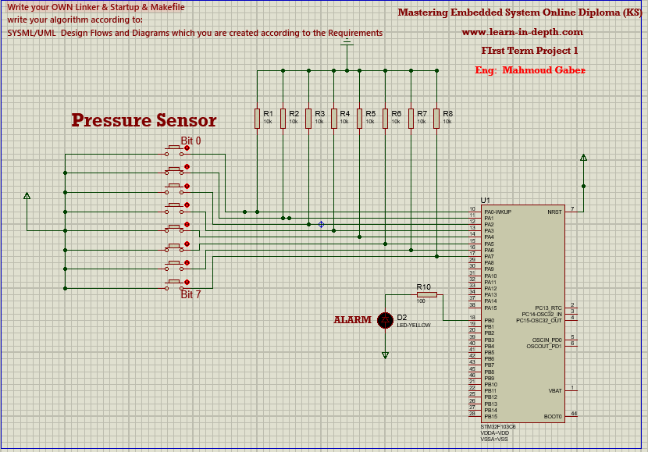

## 2- video

<https://github.com/mahmoudgaber97/term_project/tree/main/pressure%20controller>